**Source:** **http://www.baycongroup.com/access2007/index.html**

**Save your work for future labs**

**Task to be completed at the end of lesson 1:**

Create a blank database named *MusicLibrary* and save it at the desired location.

## Lesson 1: Getting Familiar with Microsoft Access 2007 for Windows

Microsoft Access is a database software package. A *database*is an organized collection of records. Telephone and address books are examples of paper databases. With Access, you can create a computerized database. For example, you can use Access to organize the students who attend a school, the courses they take, and the instructors who teach them. After you create an Access database, you can search it, manipulate it, and extract information from it. This lesson introduces you to Access windows and teaches you how to create a database.

### Create a Database

When you start Access, the Getting Started With Microsoft Office Access screen appears. You can use this screen to create a database. Within a database, you can do such things as enter data, create reports, and retrieve data.

### Create a Blank Database

A blank database is a database with nothing in it. You must create all the tables, forms, reports, queries, and so on. If you cannot find a template that suits your needs, create a blank database. After you create the database, Access opens to a datasheet and makes available the tools you need to create objects. Creating tables is the first step in building a database. You will learn more about creating tables in the next lesson.

#### To create a blank database:

|  |
| --- |
| Create Blank Database |
| Create Blank Database |

1. Start Access.
2. Click Blank Database.
3. Type the name you want to give your database in the File Name field. Access will automatically append .accdb to the name.
4. Click the Browse button. The File New Database window appears.
5. Locate the folder in which you want to store your database. Note that the name of the file appears in the File Name field.
6. Click OK.
7. Click the Create button. Access creates the database and opens a datasheet with the Table Tools available to you.

Note the Table Tools in the upper-right portion of the Ribbon.

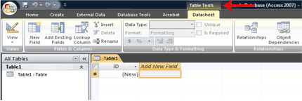

Question  **What is a Datasheet?**  
In Access, data is stored in tables. A datasheet displays the information stored in a table in columns and rows. The columns are called fields and the rows are called records. You can use a datasheet to create a table, enter data, retrieve data, and perform other tasks.

**Task to be completed at the end of lesson 2:**

In the *MusicLibrary* database, create the following tables: *tablename(field:fieldtype,…) primary key is in bold*

1. artist (**artistid:autonumber**, artistname:text, rating:number)
2. album (**albumid: autonumber** , albumname:text, **artistid:number**)
3. track (**trackid: autonumber**, trackname:text, **artistid:number**, **albumid:number**, time:date/time)
4. played (**artistid: number, albumid: number, trackid: number, playedtimestamp: date /time**)

## Lesson 2: Creating Microsoft Access Tables

Tables are the foundation of an Access database. Access stores data in tables. This lesson teaches you how to create a table, add fields to a table, assign data types to fields, and set field properties.

### Understanding Tables

A table is a set of columns and rows. Each column is called a field. Within a table, each field must be given a name and no two fields can have the same name. Each value in a field represents a single category of data. For example, a table might have three fields: Last Name, First Name, and Phone Number. The table consists of three columns: one for last name, one for first name, and one for phone number. In every row of the table, the Last Name field contains the last name, the First Name field contains the first name, and the Phone Number field contains the phone number. Each row in a table is called a record.

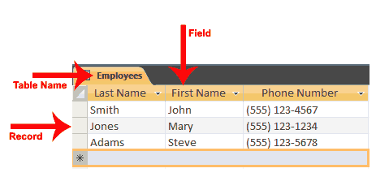

All of the data in a table should refer to the same subject. For example, all of the data in the Employees table should refer to employees, all of the data in the Students table should refer to students, and all of the data in the Courses table should refer to courses.

You can view an Access database as a collection of related tables. For example, in a database that contains tables for Employees, Students, and Courses, the Employees table lists the employees, the Students table lists students, and the Courses table lists the courses students can take.

After Access creates a blank database, it opens in Datasheet view and makes available the tools you need to create a table. Datasheet view displays a table as a set of columns and rows. When you view a blank database for the first time in Datasheet view, you see a column named ID. This column is by default the primary key field.

A primary key is a field or combination of fields that uniquely identify each record in a table. No two records in a table should have the same values in every field. For example, the following should not occur in a table.

|  |  |  |
| --- | --- | --- |
| **Last Name** | **First Name** | **City** |
| Smith | John | Jonestown |
| Smith | John | Jonestown |

In the real world, it is possible to have two people from the same city with the same first and last name. In cases like this, you can use the ID field as the primary key field and use it to make each record unique. The ID field has a data type of AutoNumber; as a result, Access automatically creates a unique number for each record in the database. The resulting table will look like the one shown here.

|  |  |  |  |
| --- | --- | --- | --- |
| **ID** | **Last Name** | **First Name** | **City** |
| 1 | Smith | John | Jonestown |
| 2 | Smith | John | Jonestown |

Access provides several methods for creating a table. One method is to use the Rename option with the Add New Field column labelto give each column the field name you want it to have and then to type or paste your data into the table. Field names can include letters, numbers, and spaces and can be up to 64 characters long. When choosing a field name, try to keep it short.

When you save your table for the first time, Access gives you the opportunity to name your table. Each table name must be unique; hence, two tables in the same database cannot have the same name. The table name should describe the data in the table; can consist of letters, numbers, and spaces; and can be up to 64 characters long. When choosing a table name, try to keep it short.

You can save a table by clicking the Save button on the Quick Access toolbar or by right-clicking the Tables tab and then choosing Save from the menu that appears.

#### To add fields to a table:

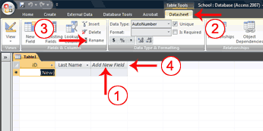

1. Click the Add New Field column label.
2. Activate the Datasheet tab.
3. Click Rename in the Fields & Columns group.
4. Type the field name.
5. Press Enter. Access creates the field.
6. Type the next field name. Access creates the field. Continue until you have created all of the fields in your table.
7. Press Enter without entering a field name to end your entries.

Or

1. Right-click the Add New Field column label. A menu appears.
2. Click Rename Column.
3. Type the field name.
4. Press Enter. Access creates the field.
5. Type the next field name. Access creates the field. Continue until you have created all of the fields in your table.

### Name and Save a Table

After you create a table, you must name and save it.

#### To name and save a table:

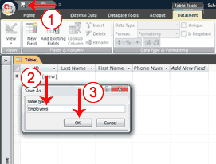

1. Click the Save button on the Quick Access toolbar. The Save As dialog box appears.
2. Type the name you want to give your table.
3. Click OK. Access names your table.

Tip **Tip**: You can use the Rename option at any time to rename any column. For example, you can rename the ID column Employee ID.

### Understanding Data Types

In Access, you use data types to specify the type of data each field can capture. A field with a data type of text can store alphabetic characters and numbers. Generally speaking, you cannot perform mathematical calculations by using a text field. For example, you can use a text field to store a street address. Unless you do some manipulation, you cannot use the numbers in the street address in mathematical calculations. You will not be able to sum or average the numbers in an address field, which is fine, because you probably do not want to. Alternatively, you can assign a Test Score field a data type of Number. You can enter numbers into the field and then average, sum, or perform other calculations with the numbers. However, you cannot enter an alphabetic character in a number field.

|  |  |  |
| --- | --- | --- |
| **Data Types** | | |
| **Data Type** | **Use** | **Notes** |
| Text | Alphanumeric data. Use for text and for numbers that are not used in mathematical calculations. Use for names, addresses, and other relatively short pieces of text. Can store up to 255 characters. | . |
| Memo | Long text. Use for long pieces of text, such as notes and long descriptions. Can store up to 64,000 characters. |  |
| Number | Numeric data. Use for numbers you want to use in mathematical calculations. | If you are working with currency, use the currency type. |
| Date/Time | Use for dates and times. |  |
| Currency | Use for currency. | Prevents rounding during calculation. |
| AutoNumber | Unique sequential numbers or random numbers automatically inserted when you create a record. Use to create a primary key. |  |
| Yes/No | Logical data. Use when only one of two values is valid. Yes/No, True/False, etc. |  |
| Hyperlink | Use to store hyperlinks. |  |
| Attachment | Use to store attachments. |  |
| OLE Object | Use to attach an OLE object such as a Word document, Excel spreadsheet, or PowerPoint presentation. |  |

After you create the fields for a table, you can enter data by typing in each field. As you type, Access assigns a data type to each field based on your entry.

|  |  |
| --- | --- |
| **Assigned Data Types** | |
| **Sample Entry** | **Data Type Assigned** |
| Smith | Text |
| http://www.website.com | Hyperlink |
| 10000 | Number, Long Integer |
| 10,000 | Number, Long Integer |
| 10,000.99 | Number, Double |
| 10000.999 | Number, Double |
| 01/01/2009  The date and time formats recognized are those of your user locale. | Date/Time |
| January 1, 2009 | Date/Time |
| 12:10:33 | Date/Time |
| 12:30 am | Date/Time |
| 16:50 | Date/Time |
| 100.50 | Number, Double |
| 25.00% | Number, Double |
| 1.23E+02 | Number, Double |

### Explicitly Assign Data Types and Formats

You may want to change the data type Access assigned to a field, or you may want to explicitly assign a data type to each field. You can do so by choosing the Datasheet tab and then selecting the proper option in the Data Type field in the Data Type & Formatting group.

Some data types allow you to select the formatting you want. By formatting, you determine how data in a field displays. For example, if you choose a data type of number and a format of Euro, any number you enter will appear with a Euro sign in front.

Windows regional settings enable you to display information such as dates, times, and currency that match the standards or language used in the country in which you live. For example, if you live in the United States, the currency setting uses a dollar sign.

|  |  |
| --- | --- |
| **Regional Settings for English (United States)** | |
| Number | 123,456,789.00 |
| Currency | $123,456,789.00 |
| Time | 3:39:44 PM |
| Short Date | 7/28/2008 |
| Long Date | Monday, July 28, 2008 |

Use the Windows Control panel’s Regional and Language options to view or change regional settings.

|  |  |  |
| --- | --- | --- |
| **Data Types** | | |
| **Data Type** | **Format** | **How Numbers Display** |
| Number | General Number | As typed. |
|  | Currency | Uses thousands separator. Follows regional settings. |
|  | Euro | Uses currency format with Euro symbol. |
|  | Fixed | Displays at least one digit. Follows regional settings. |
|  | Standard | Uses thousands separator. Follows regional setting. |
|  | Percent | Converts entry to percent. |
|  | Scientific | Uses scientific notation. |
| Currency | General Number | As typed. |
|  | Currency | Uses thousands separator. Follows regional settings. |
|  | Euro | Uses currency format with Euro symbol. |
|  | Fixed | Displays at least one digit. Follows regional settings. |
|  | Standard | Uses thousands separator. Follows regional setting. |
|  | Percent | Converts entry to percent. |
|  | Scientific | Uses scientific notation. |
| Date/Time | General Date | Date values display as numbers and time values as hours, minutes, and seconds followed by AM or PM. Follows regional settings. |
|  | Long Date | Uses the Long Date format specified in your Windows regional settings. |
|  | Medium Date | Uses dd/mmm/yy, using the date separator specified in your Windows regional settings. |
|  | Short Date | Uses the Short Date format specified in your Windows regional settings. |
|  | Long Time | Uses hours, minutes, and seconds followed by AM or PM. Uses the separator specified in the Time setting in your Windows regional settings. |
|  | Medium Time | Displays hours and minutes followed by AM or PM. Uses the separator specified in the Time setting in your Windows regional settings. |
|  | Short Time | Uses hours and minutes. Uses the separator specified in the Time setting in your Windows regional settings. |
| Yes/No |  | Yes/No True/False On/Off |

#### To explicitly assign a data type or format to a field:

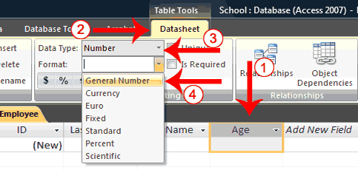

1. Click the field label for the field to which you want to assign a data type.
2. Activate the Datasheet tab.
3. Click the down-arrow next to the Data Type field and then choose a data type.
4. Click the down-arrow next to the Format field and then choose a format. Access assigns a data type and format to the field you selected.

**Tip Tip:** If you want every record in a field to be unique, check the Unique box on the Datasheet tab in the Data Type & Formatting group. If you do not want the user to leave a field blank, check the Is Required box.

**Tip** **Tip:**In the Data Type & Formatting group, there are several formatting options you can apply to numbers. If you want to use the Currency format, click the Currency button Currency Button; if you want to use the Percent format, click the Percent button Percent Button; if you want to use a Comma number format, click the Comma button Comma Button; or if you want to increase or decrease the number of decimal place, click the Increase Decimal  Increase Decimal Button or Decrease Decimal  button Decrease Decimal Button.

**Tip Tip:** You can create a new table at any time by activating the Create tab and then clicking Table.

### Understanding Design View

Access provides several ways to view the objects in your database. You can use Design view to create or modify an Access table. You can use the View button on the Home tab or the Table Design button on the Create tab to change to Design view. Using Design view is the preferred method for creating a table because it provides you with the most options and enables you to precisely define your table. In addition to selecting a data type, you can set all of the following options in Design view.

|  |  |  |
| --- | --- | --- |
| **Design View Options** | | |
| **Field Property** | **Data Type** | **Comments** |
| Field Size | Text | Enables you to restrict the number of characters stored in a text field to 0 to 255 characters. The default is 255. |
| Number | Enables you to select the type of number stored in a field. |
| **Number Types** | **Values Stored** |
| Byte | 0 to 255. (No fractions) |
| Decimal | –9.999... x 1027 through +9.999... x 1027 |
| Integer | –32,768 to +32,767 (No fractions) |
| Long Integer | –2,147,483,648 to +2,147,483,647 |
| Single | –3.4 x 1038 to +3.4 x 1038 numeric floating point values. Up to seven significant digits. |
| Double | –1.797 x 10308 to +1.797 x 10308 1038 numeric floating point values. Up to fifteen significant digits. |
| Replication ID | Globally Unique Identifier (GUID). Used by Access to establish a unique identifier for replication. |
| Format | Number | Determines how numbers display. When you use the currency, fixed, standard, and percent formats. Access follows the settings specified in Regional Settings in the Windows Control Panel for negative amounts, decimal and currency symbols, and decimal places. |
| Currency Number | General Number | Displays as typed. |
|  | Currency | Uses thousands separator. Follows regional setting. |
|  | Euro | Uses currency format with Euro symbol. |
|  | Fixed | Displays one digit. Follows regional settings. |
|  | Standard | Uses thousands separator. Follows regional settings. |
|  | Percent | Converts entry to percent. |
|  | Scientific | Uses scientific notation. |
| Date/Time | General Date | Displays date and time. Example: 01/02/99, 06:28:21 PM |
|  | Long Date | Displays Day of Week and Date: Example: Saturday, January 02, 1999 |
|  | Medium Date | Example: 02-Jan-99 |
|  | Short Date | Example: 01/02/99 |
|  | Long Time | Example: 6:28:21 PM |
|  | Medium Time | Example: 6:28 PM |
|  | Short Time | Example: 18:28 |
| Text and Memo | @ | Text character required. |
|  | & | Text character not required. |
|  | < | Changes all characters to lowercase. |
|  | > | Changes all characters to uppercase. |
| Yes/No | Yes/No | If the Lookup Display Control is a text box, displays Yes/No. |
|  | True/False | If the Lookup Display Control is a text box, displays True/False. |
|  | On/Off | If the Lookup Display Control is a text box, displays On/Off. |
| Decimal Places | Determines number of decimal places Access displays. | Auto. Number of decimals displayed depends on the format setting. |
|  |  | 0–15. Used with format property. Determines the number of digits that display to the right of the decimal point. |
| Input Mask | Special characters used to control the values the user can input. |  |
| Caption | Field name displayed on forms. |  |
| Default Value | Sets the value that appears in the field by default when a record is created. |  |
| Validation Rule | Sets the requirements for user input. |  |
| Validation Text | Text for error messages that are sent when validation rules are broken. |  |
| Required | Specifies whether the field is required or not. | Yes: Required No: Not Required |
| Allow Zero Length | Determines whether a zero-length field is a valid entry. | Yes: Is valid No: Not valid |
| Index | Specifies whether an index should be created in a field. Indexes speed up queries. | Yes: Create index. No: Do not create index. |

#### To use Design view to create a new table:

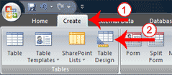

1. Activate the Create tab.
2. Click Table Design in the Tables group. Access changes to Design view and the Table Tools become available.

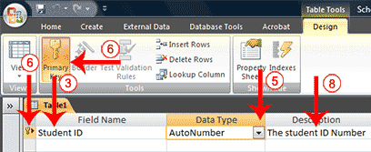

1. Type the first field name in the Field Name field.
2. Press the Tab key.
3. Click the down-arrow that appears when you click in the Data Type field and then select a data type.
4. Click Primary Key if the column you created is a primary key. A small key appears next to the field name. If the primary key consists of multiple fields, select the required multiple rows by pressing the Ctrl key and then using the mouse to click on the required fields, then click the primary key button shown in the figure.
5. Press the Tab key.
6. Type a description. The description is optional.
7. Press the Tab key. Access moves to the Field Name field.
8. Repeat steps 3 through 10 until you have created all of your fields.

#### To set field properties:

|  |
| --- |
| Set Field Properties |
| Set Field Properties |

1. Click the field for which you want to set the field properties.
2. Activate the General tab in the Field Properties area.
3. Set the properties you want to set.
4. Repeat steps 1 through 3 until you have set all the properties for all fields.

You can use Design view to create or modify a table. After you finish the task, you must save the table by clicking the Save button on the Quick Access toolbar.

1. Click the Save button on the Quick Access toolbar. Access saves the table unless you are saving for the first time. If you are saving for the first time, the Save As dialog box appears.
2. Type the name you want to give your table.
3. Click OK. Access saves the table. You can now access the table by using the Navigation pane.

Question **What are views?**  
Views are different ways of looking at the same object. Tables have four views: Datasheet view, Pivot Table view, Pivot Chart view, and Design view. You use Datasheet view to create a table, edit data, or view data; Pivot Table view to create a pivot table; Pivot Chart view to create a pivot chart; and Design view to create a table or modify an existing table.

#### To change the view:

1. Activate the Home tab.
2. Click the down-arrow under the View button. A menu appears.
3. Click the view you want. Access changes to the view you chose.

**Task to be completed at the end of lesson 3:**

1. Create a new Excel file named *artist*. Create three columns, artistid, artistname, rating. Populate the table with at least five rows. In the artistid field use the numbers 1, 2, 3, 4, and 5. Import this table to the artist table in your database.
2. Delete the rating field from the artist table from access.
3. Populate the album table with at least five rows. Make sure the value in the artistid field exists in the artist table.
4. Populate the track table with at least five rows. Make sure the value in the artistid and albumid fields exist in the artist and album tables respectively.
5. Populate the played table with at least six rows.
6. Delete any one row from the played table.

## Lesson 3: Working with Microsoft Access Tables

After you create an Access table, you can modify it, enter data into it manually or import data from somewhere else, such as Excel. This lesson teaches you how to modify a table and enter data.

### Enter Records

After you have created a table, you can enter data into it.

#### To enter data into an AutoNumber field:

* Press the Tab key. When you make an entry into another field in the record, Access will automatically make an entry into the AutoNumber field.

#### To enter data into fields that have a lookup list:

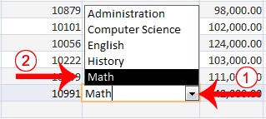

1. Click the down-arrow that appears when you click in the field.
2. Click to select the entry you want.
3. Press the Tab key.

#### To enter data into a Yes/No field:

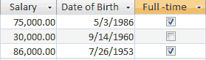

* Click the checkbox for Yes; leave the checkbox unchecked for No.

#### To add an attachment to an attachment field:

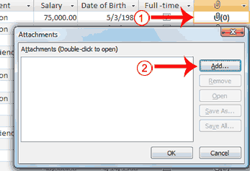

1. Double-click in the attachment field. The Attachments dialog box appears.
2. Click Add. The Choose File dialog box appears.

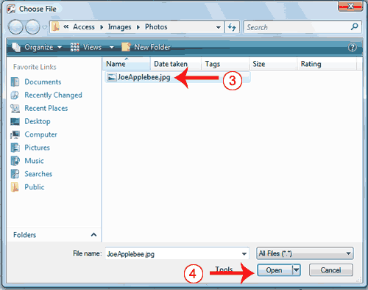

1. Click the file you want to add.
2. Click Open. The Choose File dialog box closes.

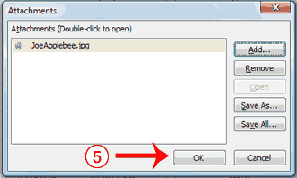

1. Click OK. Access attaches the file.

**Note:** You can attach multiple files to a single attachment field.

#### To enter data into a date field:

* Type the date.

Or

* Select the date from the calendar that appears to the left of the field when you click in the field. You click the calendar to open it. Use the left-arrow at the top of the calendar to move to the previous month; use the right-arrow at the top of the calendar to move to the next month. When you reach the proper month, click the proper date.

Date 1

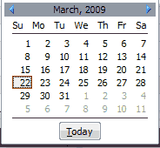

#### To add data to an OLE Object field:

An OLE object is an object such as a Word document or an Excel Spreadsheet.

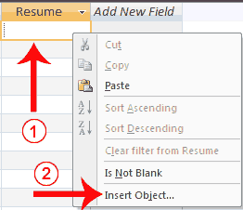

1. Right-click in the field. A menu appears.
2. Click Insert Object. The Microsoft Office Access dialog box appears.

#### Create New:

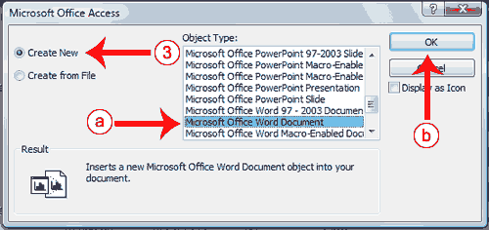

1. Click the Create New radio button if you want to create a new object.
   1. Click the object type you want to create.
   2. Click OK. Access opens the program for the object type you selected. You can create the object.
   3. Create the object and then close the program for the object type you selected. Access links to the object.

#### Create From File:

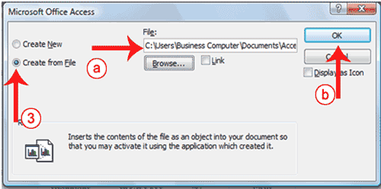

1. Click the Create From File radio button if you want to use an existing file.
   1. Type the path to the file or click the Browse button and locate the file.
   2. Click OK. Access links to the object.

#### To add data to other field types:

For all other fields, type your entry and then press the Tab key.

### Import a Table into Access from Excel

Excel organizes data into columns and rows. If you have data in Excel that you want to use in Access, you can import those columns and rows into Access by using the Excel Spreadsheet Wizard.

#### To import data from Excel:

##### Open the Excel Spreadsheet Wizard

|  |
| --- |
| Excel Wizard Step 1 |
| Excel Wizard Step 2 |

1. Activate the External Data tab.
2. Click the Excel button in the Import group. The Get External Data – Excel Spreadsheet Wizard appears.
3. Click the Browse button. The File Open window appears.
4. Locate the spreadsheet you want to import.
5. Click the Open button. The path to the file you selected appears in the File Name field.
6. Click OK. Access moves to the next page.

##### Choose the sheet or named range you want to import

When importing from Excel, you can import an entire worksheet or a named range. To import a worksheet, click the Show Worksheets radio button and then click the worksheet you want. To import a named range, click the Show Named Ranges radio button and then click the named range you want.

|  |
| --- |
| Excel Wizard Step 2 |
| Excel Wizard Step 2 |

1. Click Show Worksheets to import a worksheet, or click Show Named Ranges to import a named range.
2. Click the worksheet or named range you want to import.
3. Click Next. Access moves to the next page.

##### Make the first row your field names

When you create a worksheet in Excel, the first row can contain column headings. If this is the case, click First Row Contains Column Headings, otherwise click Next.

|  |
| --- |
| Excel Wizard Step 3 |
| Excel Wizard Step 3 |

1. Click First Row Contains Column Headings if the first row of your Excel spreadsheet contains column headings.
2. Click Next. Access moves to the next page.

##### Set data types

Access attempts to assign the correct data type to each column. You can view the assignment made by Access and then make changes. An Index speeds up Access’s ability to search a column. You can use the Indexed field to assign an index. The Yes (Duplicates OK) option creates an index in which duplicate values in the field are allowed; the Yes (No Duplicates) option creates an index in which duplicate values in the field are not allowed. The primary key should be indexed and you should use the Yes (No Duplicates) option. You can also skip fields you do not want to import.

|  |  |
| --- | --- |
| Excel Wizard Step 4 | Excel Wizard Step 4 |

1. Click a column heading to select a column.
   1. Type the Access table’s column heading in the Field Name field.
   2. Choose a Data type.
   3. Indicate if the field should be indexed and, if so, select the type of index.
   4. Check the Do Not Import Field box for any column you do not want to import.
2. Click Next. Access moves to the next page.

##### Choose a primary key

|  |
| --- |
| Excel Wizard Step 5 |
| Excel Wizard Step 5 |

You can let Access assign the primary key, choose the primary key yourself, or have no primary key by selecting the correct option on this page.

1. Click to choose the proper radio button. If you want Access to add the primary key, click Let Access Add Primary key. If you want to add the primary key, click Choose My Own Primary Key and then click the down-arrow and select the field you want to use as the key field. If you do not want to add a primary key, click No Primary Key.
2. Click Next. Access moves to the next page.

##### Name your table

|  |
| --- |
| Excel Wizard Step 6 |
| Excel Wizard Step 6 |

1. Type the name you want to give your table.
2. Click Finish. Access moves to the next page.
3. Click Close. Access imports the table.

### Modify a Table

After you create a table, you may need to modify it. You can delete columns, insert columns, or move columns.

**Delete Columns**

The Delete option permanently deletes columns and all the data contained in them. You cannot undo a column delete.

#### To delete columns:

|  |
| --- |
| Delete Column |
| Delete Column |

1. Click and drag to select the columns you want to delete.
2. Activate the Datasheet tab.
3. Click Delete in the Fields & Columns group. A prompt appears.
4. Click Yes. Access deletes the columns you selected.

**Insert Columns**

The Insert option inserts a column before the selected column.

#### To insert a column:

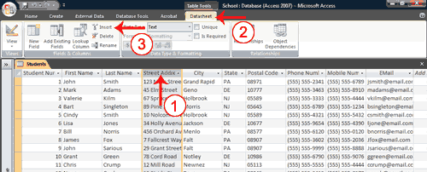

1. Click the column head of the column before which you want to insert a column.
2. Activate the Datasheet tab.
3. Click Insert in the Fields & Columns group. Access inserts a new column.

**Tip Tip:**If you right-click a column label, you can use the menu that appears to insert or delete columns.

#### To delete a column:

1. Right-click the column head you want to delete. A menu appears.
2. Click Delete Column.

#### To insert a column:

1. Right-click the column head before which you want to insert a column. A menu appears.
2. Click Insert Column.

**Move a Column**  
You can use the Move option to move a column from one location to another.

#### To move a column:

1. Move your mouse pointer over the horizontal line under the column label. Your mouse pointer turns into a four sided arrow.
2. Press your left mouse button
3. Click and drag the field to the new location. A dark line appears at the new location.
4. Release you left mouse button. Access moves the column.

### Move around a Table

Access provides several methods for moving around a table. On the Home tab, there is a Go To button. When you click it, a menu of options appears. You can use the menu to go to the first, last, previous, or next record in your table. You can click the New option to add a new record. You can also use special keys and the navigation bar in Access to move around a table. The navigation bar appears at the bottom of the table.

#### To use the Go To button to move around a table:

|  |
| --- |
| Move Around with Go To Button |
| Move Around with Go To Button |

1. Activate the Home tab.
2. Click the Go To button in the Find group. A menu appears.
3. Click First to go to the first record, Previous to go to the previous record, Next to go to the next record, Last to go to the last record, or New to create a new record.

**Tip Tip:** You can also create a new record by choosing the Home tab and then clicking New in the Records group.

#### To use keys to move around a table:

|  |  |
| --- | --- |
| **Key to Press** | **Action** |
| Tab | Moves to the next field to the right. If you are in the last field in a record, moves you to the next record. If you are in the last record in a table, creates a new record. |
| Left-Arrow | Moves to the next field to the left. If you are in the first field in a record, moves you to the previous record. |
| Shift+Tab | Moves to the previous field. If you are in the first field in a record, moves you to the previous record. |
| Right-Arrow | Moves to the next field. If you are in the last field in a record, moves you to the next record. If you are in the last record in a table, creates a new record. |
| Up-Arrow | Moves you up one record. |
| Down-Arrow | Moves you down one record. |
| Ctrl++ | Creates a new record. |

#### To use the Navigation bar to move around a table:

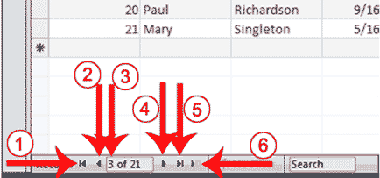

|  |  |
| --- | --- |
| 1 | Go to First Record |
| 2 | Go to Previous Record |
| 3 | The Current Record |
| 4 | Go to Next Record |
| 5 | Go to Last Record |
| 6 | Create a New (Blank) Record |

### Select Columns and Rows

Before you can perform an operation on a column or row, you must select it. To select a column, click the column head. To select several columns, click a column head and then drag. To select a row, click the blank area to the left of the row. To select several rows, click the blank area to the left of a row and then drag. To select the entire table, click the Select All button http://www.baycongroup.com/access2007/images/03_SelectAll.gif in the upper-left corner of the table.

|  |
| --- |
| Select Column |
| Select Column |

|  |
| --- |
| Select Rows |
| Select Rows |

### Delete a Record

If enter a record by error, you can delete it.

#### To delete a record:

1. Select the record you want to delete.
2. Activate the Home tab.
3. Click Delete in the Records group. A prompt appears.
4. Click the Yes button.

Or

* Select the record you want to delete.
* Right-click. A menu appears.
* Click Delete Record. A prompt appears.
* Click the Yes button.

### Resize a Column or Row

If all of the information in a column or row does not display, you may want to make the column or row larger. If you want to fit more information on the screen, you may want to make a column or row smaller. In either case, you can click and drag to increase or decrease column width or row height.

#### To resize a column or row:

1. Place the cursor over the line that separates two columns or two rows. The cursor turns into a double-sided arrow.
2. Hold down the left mouse button and drag to increase or decrease the width of a column or the height of all of the rows.